ISSUE 4
Sharing
Healthcare
2008

Knowledge

to meet THE extrAoRdinary challenges you are facing today
you must DEMONSTRATE extrAoRdinary business practices:

Defining Department Complexity “Degree of Difficulty”:
Creating Superior Performance with Leadership Alignment

Healthcare is the most challenged industry in America. With the increasing pressure brought about by the current economic conditions it is no surprise that hospital executive teams are examining all possible options to secure their short-term and long term success. One area that is overlooked is leadership alignment as it relates to the “Degree of Difficulty” of hospital departments. Although all departments and functions can be considered difficult, some are clearly more difficult than others. Simply put, not all departments are created equal.

Our research, having measured thousands of leaders, directors and managers, has concluded that talent alignment is the ultimate lever in driving results and desired outcomes. The more correctly aligned the talent of a leader is to a particular department’s Degree of Difficulty, the higher the probability that department will be successful and meet its performance objectives – by any measure.

According to Tom Olivo, president of Success Profiles:


How Talent Alignment Increases your Odds of Success
According to Tom Olivo, president of Success Profiles, “When organizations have a structured approach in place to align the complexity of departments/functions with the talent level of the leaders, the odds of success (in creating high performance) are increased significantly.”

“When organizations have a structured approach in place to align the complexity of departments/functions with the talent level of the leaders, the
odds of success (in creating high performance) are increased significantly.”

Success Profiles has established a litmus-test guide that classifies three levels of complexity or Degree of Difficulty (DoD): Low, Medium, and High. The higher the Degree of Difficulty the more complex the department is operationally and the more difficult it is to manage.

A department’s Degree of Difficulty (DoD) is determined by scoring department-related criteria on a scale of 0-4 (0 being Never and a rating of 4 being Always).

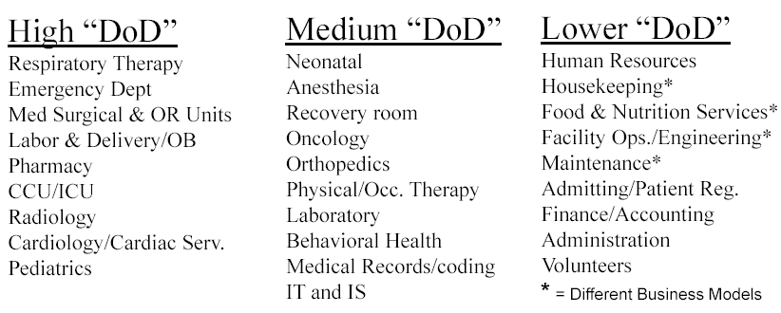

The five categories of complexity are:

- Does the department experience high volume or a very fast pace?
- Does the department generate significant revenue for the organization?
- Does the work require an advanced education or a unique skill set?
- Does the department require people who are considered to be scarce in your marketplace?
- Does the work in the department create a high amount of emotional stress?

The cut off points for DoD are as follows:
- Low Degree of Difficulty: 0 - 9 pts.
- Medium Degree of Difficulty: 10 -14 pts.
- High Degree of Difficulty: 15 - 20 pts.

For instance, a department with a total score of 17 overall points would be considered as a department with a high Degree of Difficulty.

According to assessments evaluated by hundreds of healthcare executives, typical
DoD examples include:

- the Emergency Department-usually considered to be “High” DoD,
- the Physical Therapy Department usually considered to be Medium” DoD and

- Housekeeping is most often considered to be “Low” DoD. (See the insert above for other examples of complexity or DoD.)

The list of departments above serves as a guide to help determine the overall complexity level of service lines or departments typically found within an acute care environment. Each DoD category is actually sorted in rank order from data compiled from leadership teams in over 200 healthcare organizations.

It should be noted that this list should serve as a guide and that it’s possible for your organization to experience higher DoD for any function. Also, a leaders relative odds of success cannot be enhanced by artificially increasing a departments’ DoD rank.

The overall message is simple but very powerful: When leadership talent (demonstrated ability) is appointed to the appropriate level of complexity (DoD), the odds of success in creating high performance are stacked 2 to 1 in your favor. When out of alignment, the odds of success are stacked 3 to 1 against.


RIGHT PEOPLE, RIGHT ROLES

